TR-NPI-803
产品简介 General Information
- TR-NPI-803是一款大分子活性胺助剂。其低迁移、低挥发的特性，是专门为油墨应用设计的。TR-NPI-803特别适合和II类引发剂协同使用。
- TR-NPI-803 is a polymeric amine synergist. It has low migration and low volatility, which is specifically designed for use in inks. TR-NPI-803 is particularly suited to use in combination with Type II photoinitiators.
产品信息 Product Information
- 化学名称 Chemical Name：聚乙二醇二-(对-二甲基氨基苯甲酸)酯 Polyethylene glycol di-(p-dimethylaminobenzoate) ester
- CAS No：71512-90-8
紫外吸收光谱 UV Absorbance Spectrum
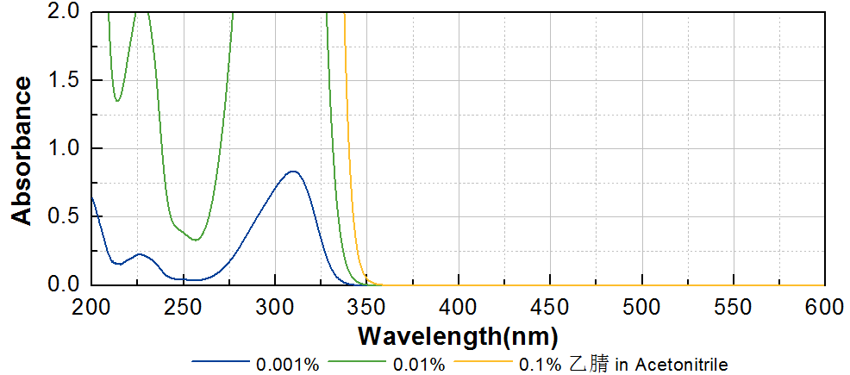

技术参数 Technical Parameters
- 外观 Appearance：黄棕色粘稠液体 Yellow-brown viscous liquid
- EDB含量 EDB Content (HPLC)：≤1.00%
- 干燥失重 Loss on Drying：≤0.10%
产品优势 Benefits
- 低迁移、低挥发 Low migration and low volatility
- 特别适用于黑色和深色体系 Especially suitable for black and dark systems
应用 Applications
- TR-NPI-803特别适合和II类引发剂协同使用，建议添加量为5~15%。
- TR-NPI-803 is particularly suited to use in combination with Type II photoinitiators. The recommended dosage is 5~15%.
存储及包装 Storage & Packaging
- 保存在密闭容器中储存在阴凉、干燥、阴暗、通风的区域。自生产日期开始，1年内有效。包装：20kg/桶；200kg/桶。
- Keep in a tightly closed container and store in a cool, dry, dark, ventilated area. Effective from the date of production, within 1 years. Packaging: 20kg/pail, 200kg/drum.

THE END

