TR-EMK
产品简介 General Information
- TR-EMK是一款通用型自由基光引发剂，也能起到活性胺助剂的效果。其吸收波长长，溶解性好，主要作为其他自由基光引发剂的增感剂使用，特别适用于黑色和深色体系。
- TR-EMK is a general free radical photoinitiator, which can also play the role of active amine assistant. With long absorption wavelength and good solubility, it is mainly used as sensitizer of other free radical photoinitiators, especially suitable for black and dark systems.
产品信息 Product Information
- 化学名称 Chemical Name：四乙基米氏酮 4,4'-Bis(diethylamino) benzophenone
- 分子量 Molecular Weight：324.46
- CAS No：90-93-7
紫外吸收光谱 UV Absorbance Spectrum
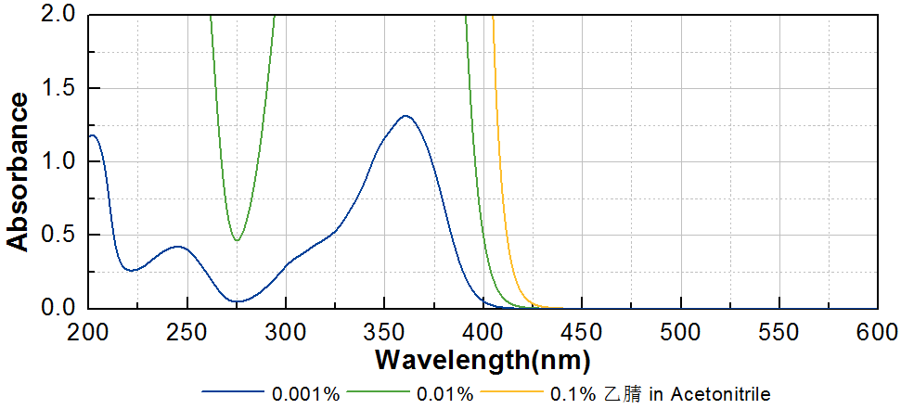
技术参数 Technical Parameters
- 外观 Appearance：淡黄色粉末 Light yellow powder
- 纯度 Purity (HPLC)：≥98.00%
- 熔程 Melting Range：92.0~98.0ºC
- 干燥失重 Loss on Drying：≤0.50%
产品优势 Benefits
- 长吸收波长 Long absorption wavelength
- 优秀的溶解性 Great solubility
- 特别适用于黑色和深色体系 Especially suitable for black and dark systems
应用 Applications
- TR-EMK可作为其他自由基引发剂的增感剂使用，大量应用于色墨和电子电路有色材料。当作为引发剂使用时，建议添加量为3~5%；当作为增感剂使用时，建议添加量为1~3%。
- TR-EMK can be used as sensitizer of other free radical photoinitiators. It’s widely used in ink and electronic circuit colored materials. The recommended dosage as photoinitiator is 3~5%. The recommended dosage as sensitizer is 1~3%.
存储及包装 Storage & Packaging
- 保存在密闭容器中储存在阴凉、干燥、阴暗、通风的区域。自生产日期开始，2年内有效。包装：20kg/箱。
- Keep in a tightly closed container and store in a cool, dry, dark, ventilated area. Effective from the date of production, within 2 years. Packaging: 20kg/carton.

THE END

