TR-PSS-306
产品简介 General Information
- TR-PSS-306是一款通用型增感剂，也可作为长波长通用型光引发剂使用。TR-PSS-306主要用于长波长阳离子体系固化，用于提高反应活性和深层固化效果。
- TR-PSS-306 is a general sensitizer which could be used as free radical photoinitiator with long absorption wavelength. TR-PSS-306 is mainly used for long wavelength cation curing to improve activity and deep curing performance.
产品信息 Product Information
- 化学名称 Chemical Name：9, 10-二乙氧基-2-乙基蒽 9, 10-Diethoxy-2-ethylanthracene
- 分子量 Molecular Weight：294.00
- CAS No：205515-07-7
紫外吸收光谱 UV Absorbance Spectrum
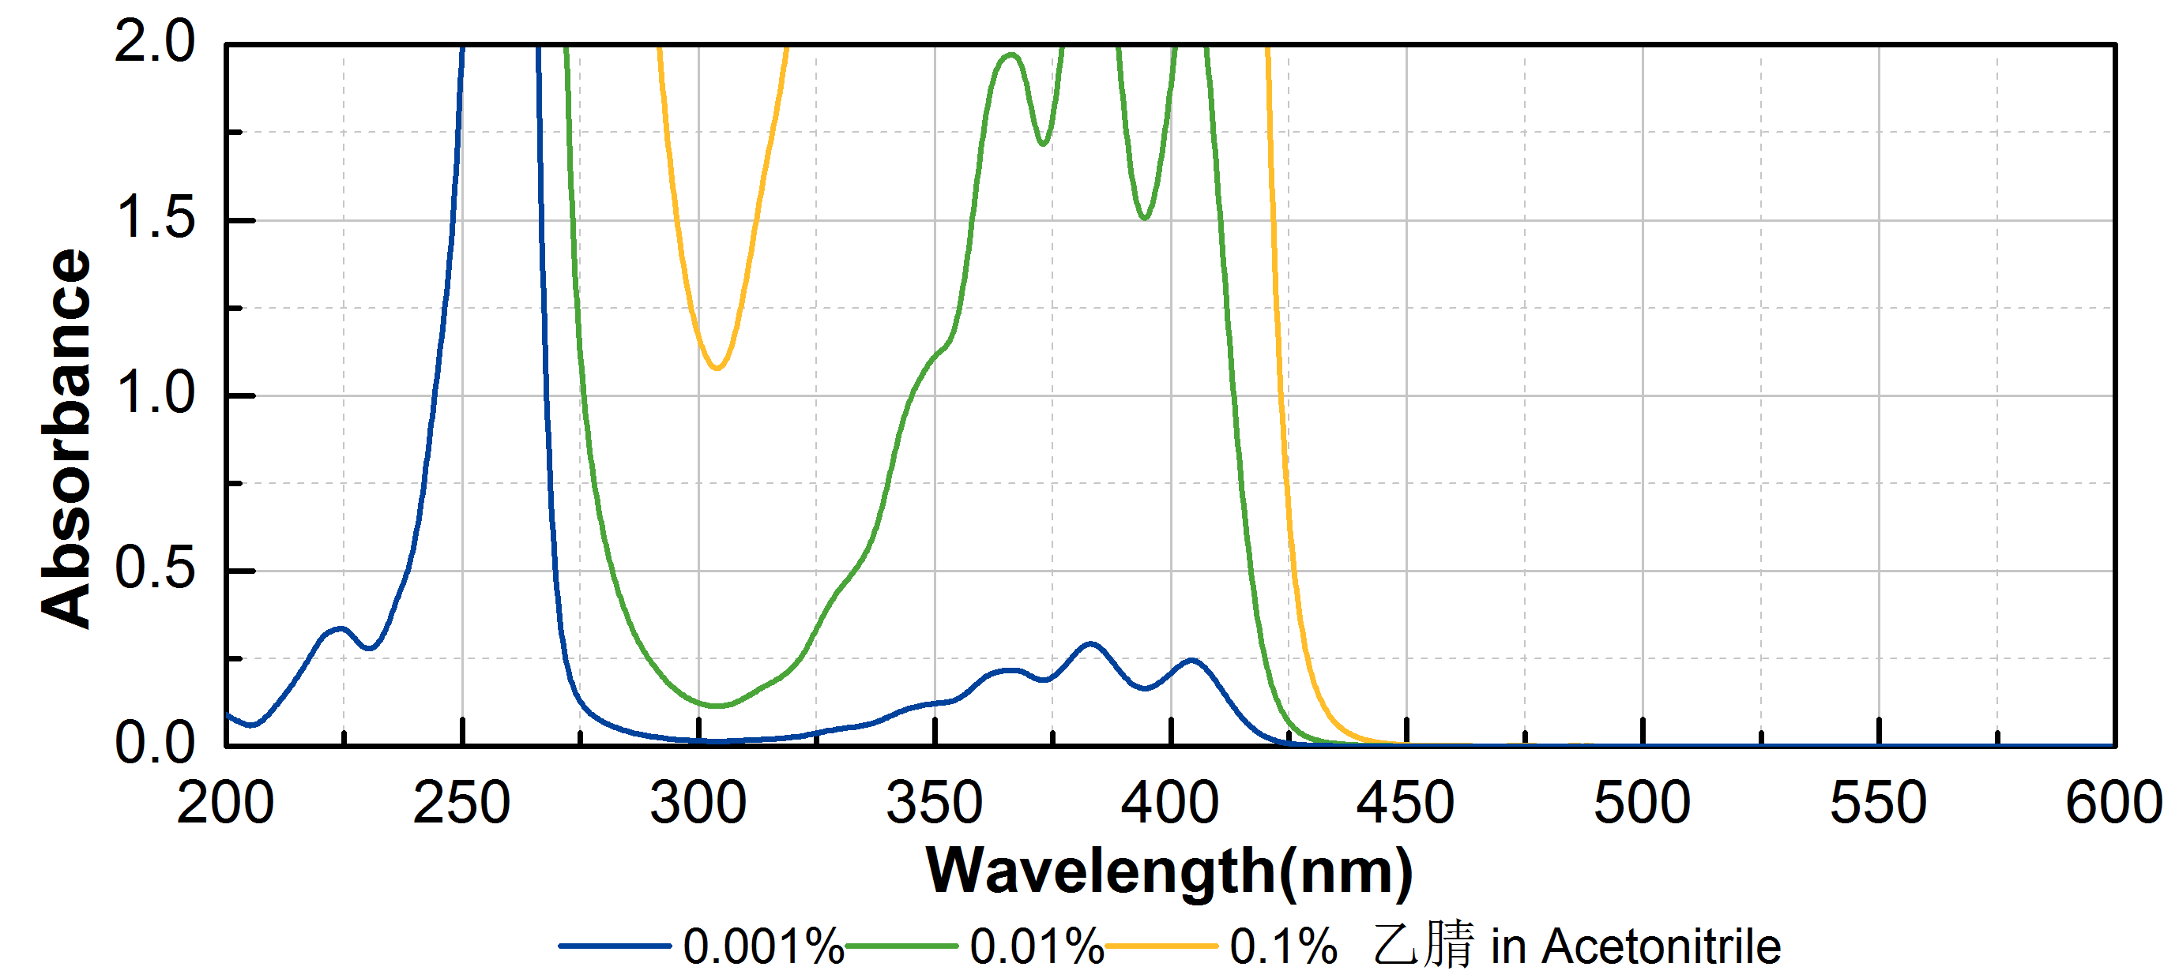
技术参数 Technical Parameters
- 外观 Appearance：黄色粉末 Yellow powder
- 纯度 Purity (HPLC)：≥98.00%
- 干燥失重 Loss on Drying：≤0.50%
产品优势 Benefits
- 优秀的活性 Excelle reactivity
- 长吸收波长 Long absorption wavelength
- 良好的深层固化 Good deep curing performance
应用 Applications
- TR-PSS-306常作为阳离子体系的增感剂使用，建议添加量约为0.5~1%。
- TR-PSS-306 can be used as sensitizer in cation curing, a level of approximately 0.5~1% is recommended.
存储及包装 Storage & Packaging
- 保存在密闭容器中储存在阴凉、干燥、阴暗、通风的区域。自生产日期开始，2年内有效。包装：20kg/桶。
- Keep in a tightly closed container and store in a cool, dry, dark, ventilated area. Effective from the date of production, within 2 years. Packaging: 20kg/drum.

THE END

