TR-PSS-303
产品简介 General Information
- TR-PSS-303是一款通用型增感剂，也可作为长波长通用型光引发剂使用。TR-PSS-303主要用于长波长阳离子体系固化，用于提高反应活性和深层固化效果。
- TR-PSS-303 is a general sensitizer which could be used as free radical photoinitiator with long absorption wavelength. TR-PSS-303 is mainly used for long wavelength cation curing to improve activity and deep curing performance.
产品信息 Product Information
- 化学名称 Chemical Name：9,10-二丁氧基蒽 9,10-Dibutoxyanthracene
- 分子量 Molecular Weight：322.44
- CAS No：76275-14-4
紫外吸收光谱 UV Absorbance Spectrum
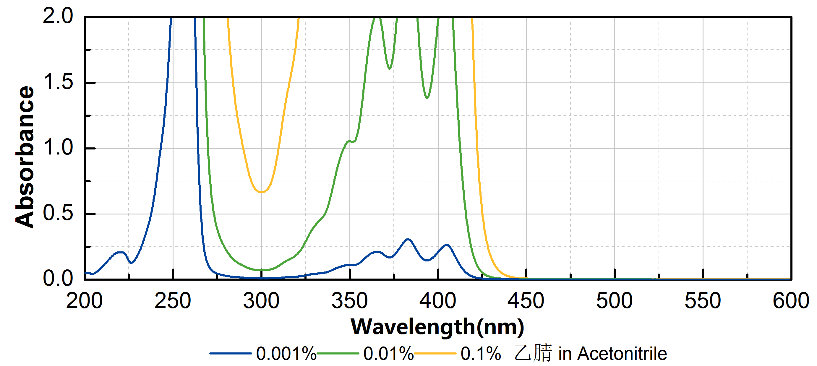
技术参数 Technical Parameters
- 外观 Appearance：黄色晶体粉末 Yellow crystalline powder
- 纯度 Purity (HPLC)：≥98.00%
- 熔程 Melting Range：105.0~115.0ºC
- 干燥失重 Loss on Drying：≤0.50%
产品优势 Benefits
- 高活性 High reactivity
- 长吸收波长 Long absorption wavelength
- 良好的深层固化 Good deep curing performance
应用 Applications
- TR-PSS-303常作为阳离子体系的增感剂使用，建议添加量约为0.5~1%。
- TR-PSS-303 can be used as sensitizer in cation curing, a level of approximately 0.5~1% is recommended.
存储及包装 Storage & Packaging
- 保存在密闭容器中储存在阴凉、干燥、阴暗、通风的区域。自生产日期开始，1年内有效。包装：20kg/桶。
- Keep in a tightly closed container and store in a cool, dry, dark, ventilated area. Effective from the date of production, within 1 year. Packaging: 20kg/drum.

THE END

