TR-PSS-206
产品简介 General Information
- TR-PSS-206是一款通用型增感剂，也可作为通用型光引发剂使用。其具备长吸收波长和优秀的深层固化性能，以及良好的溶解性和优秀的热稳定性，与其他光引发剂搭配可作为TR-TPO的替代品使用。TR-PSS-206特别适用于有色体系的光固化，尤其是对固化深度要求极高的场景，有极佳的表现。
- TR-PSS-206 is a general sensitizer which could be used as free radical photoinitiator with long absorption wavelength, excellent deep curing performance, good solubility and excellent thermal stability. When used in combination with other photoinitiators, TR-PSS-206 could be used as a substitute for TR-TPO. TR-PSS-206 has excellent performance for colored curing, especially for scenes with extremely requirements for curing depth.
产品信息 Product Information
- 化学名称 Chemical Name：保密 Confidential
- 分子量 Molecular Weight：保密 Confidential
- CAS No：保密 Confidential
紫外吸收光谱 UV Absorbance Spectrum
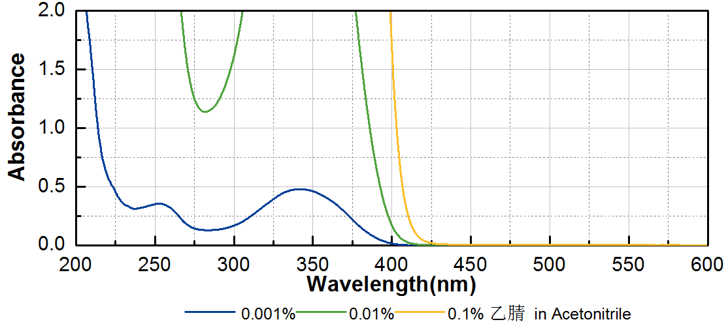
技术参数 Technical Parameters
- 外观 Appearance：类白色粉末 Off-white powder
- 纯度 Purity (HPLC)：≥99.00%
- 熔程 Melting Range：76.0~78.0ºC
- 干燥失重 Loss on Drying：≤0.30%
产品优势 Benefits
- 高反应活性 High initiating activity
- 长吸收波长 Long absorption wavelength
- 良好的溶解性 Good solubility
- 优秀的热稳定性 Excellent thermal stability
- 优秀的深层固化性能 Excellent deep curing performance
应用 Applications
- TR-PSS-206可以作为增感剂，也常作为光引发剂使用。作为增感剂使用的建议添加量约为0.5~1%。作为光引发剂使用的建议添加量约为3~5%。当和活性胺协同使用时，TR-PSS-206常作为TR-TPO的替代产品使用。TR-PSS-206和活性胺按照3:1的比例混合后，可以等比例替代TR-TPO。
- TR-PSS-206 can be used as sensitizer or photoinitiator. When used as sensitizer, a level of approximately 0.5~1% is recommended. When used as photoinitiator, a level of 3~5% is recommended. When used in combination with active amine, TR-PSS-206 is usually used as a substitute for TR-TPO. After TR-PSS-206 and active amine are mixed in the proportion of 3:1, they can replace TR-TPO in equal proportion.
存储及包装 Storage & Packaging
- 保存在密闭容器中储存在阴凉、干燥、阴暗、通风的区域。自生产日期开始，1年内有效。包装：按订单生产。
- Keep in a tightly closed container and store in a cool, dry, dark, ventilated area. Effective from the date of production, within 1 year. Packaging: make to order.

THE END

