TR-PAG-30201P
产品简介 General Information
- TR-PAG-30201是一款通用阳离子光引发剂。其毒性低，稳定性好，主要应用于涂料、油墨等基础阳离子体系。
- TR-PAG-30201 is a general cationic photoinitiator, which has low toxicity and good stability. It’s mainly used in basic cationic systems such as coating and ink.
产品信息 Product Information
- 化学名称 Chemical Name：双(4-叔丁基苯)碘鎓六氟磷酸盐碳酸丙烯酯溶液 Bis(4-tert-butylphenyl) iodonium hexafluorophosphate salt propylene carbonate solution
- CAS No：61358-25-6, 108-32-7
紫外吸收光谱 UV Absorbance Spectrum
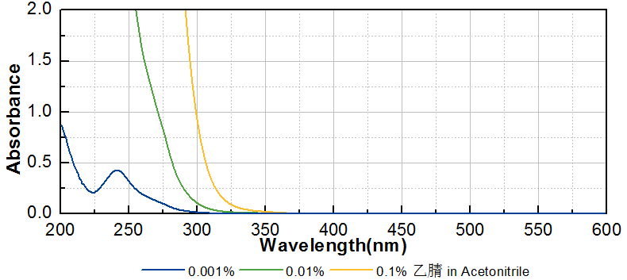
技术参数 Technical Parameters
- 外观 Appearance：淡黄色透明液体 Light yellow transparent liquid
- 纯度 Purity(HPLC)：≥99.00%
- 固含量 Solid Content：48.50~51.50%
- 干燥失重 Loss on Drying：≤0.50%
产品优势 Benefits
- 低毒性 Low toxicity
- 高稳定性 Good stability
应用 Applications
- TR-PAG-30201主要用于环氧树脂涂料和特种油墨，建议添加量为3~5%。
- TR-PAG-30201 is mainly used for epoxy coating and special ink. The recommended dosage is 3~5%.
存储及包装 Storage & Packaging
- 保存在密闭容器中储存在阴凉、干燥、阴暗、通风的区域。自生产日期开始，2年内有效。包装：20kg/桶。
- Keep in a tightly closed container and store in a cool, dry, dark, ventilated area. Effective from the date of production, within 2 years. Packaging: 20kg/drum.

THE END

