TR-PAG-202
产品简介 General Information
- TR-PAG-202是一款通用型阳离子光引发剂，溶解在碳酸丙烯酯中以便于使用。其毒性小，性价比高，是最为成熟的阳离子光引发剂之一，主要应用于涂料、油墨等基础阳离子体系。
- TR-PAG-202 is a general cationic photoinitiator, which is dissolved in propylene carbonate for easy use. With low toxicity and high cost performance, it is one of the most mature cationic photoinitiators, mainly used in basic cationic systems such as coating and ink.
产品信息 Product Information

- 化学名称 Chemical Name：混合型三苯基六氟磷酸硫鎓盐碳酸丙烯酯溶液 Mixed type triphenyl sulfonium hexafluorophosphate salt propylene carbonate solution
- CAS No：75482-18-7, 74227-35-3, 108-32-7
紫外吸收光谱 UV Absorbance Spectrum
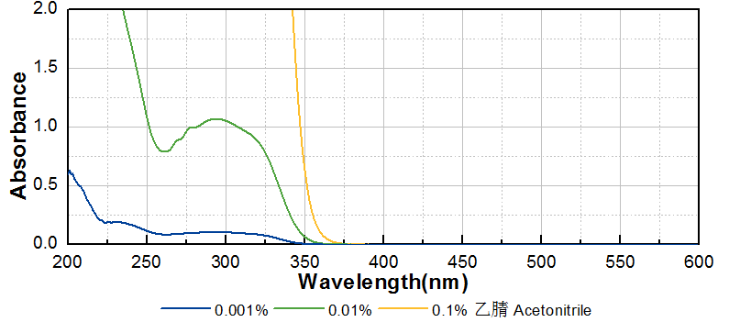
技术参数 Technical Parameters
- 外观 Appearance：淡黄色透明液体 Light yellow transparent liquid
- 固含量 Solid Content：≥40.00%
- 水分 Water Content：≤1.00%
- 色度 Chromaticity：≤4.0
产品优势 Benefits
- 低毒性 Low toxicity
- 优良的性价比 Good cost effectivity
应用 Applications
- TR-PAG-202主要用于环氧树脂涂料和特种油墨，建议添加量为3~5%。
- TR-PAG-202 is mainly used for epoxy coating and special ink. The recommended dosage is 3~5%.
存储及包装 Storage & Packaging
- 保存在密闭容器中储存在阴凉、干燥、阴暗、通风的区域。自生产日期开始，2年内有效。包装：25kg/桶；250kg/桶；1000kg/桶。
- Keep in a tightly closed container and store in a cool, dry, dark, ventilated area. Effective from the date of production, within 2 years. Packaging: 25kg/pail; 250kg/drum; 1000kg/IBC.

THE END

