TR-4-PBZ
产品简介 General Information
- TR-4-PBZ是一款通用型自由基光引发剂，常作为TR-BP的改进版使用。TR-4-PBZ具有高引发效率、低气味的特性，广泛应用于木器涂料和光油。
- TR-4-PBZ is a general free radical photoinitiator, often used as an improved version of TR-BP. It’s high initiation efficiency and low odor. It’s widely used in wood coating and varnish.
产品信息 Product Information
- 化学名称 Chemical Name：4-苯基二苯甲酮 4-Phenyl-benzophenon
- 分子量 Molecular Weight：258.31
- CAS No：2128-93-0
紫外吸收光谱 UV Absorbance Spectrum
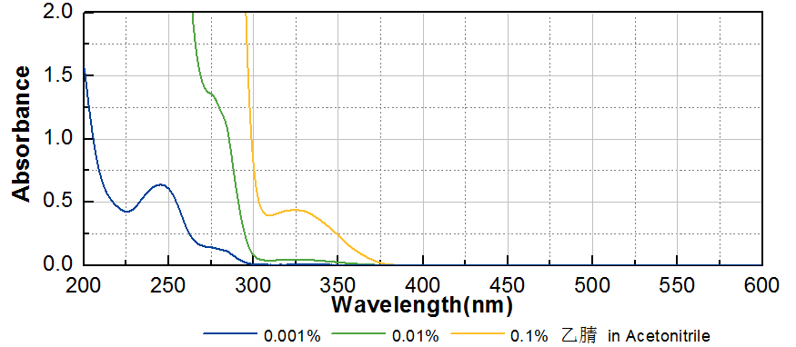
技术参数 Technical Parameters
- 外观 Appearance：白色晶体粉末 White crystalline powder
- 纯度 Purity (HPLC)：≥98.00%
- 熔程 Melting Range：100.0~105.0ºC
- 干燥失重 Loss on Drying：≤0.50%
产品优势 Benefits
- 高反应活性 High reactivity
- 低气味 Low odor
应用 Applications
- TR-4-PBZ可以用于直接替代TR-BP，以获得更低气味的光固化产品，广泛应用在木器涂料和光油。建议添加量为3~5%。
- TR-4-PBZ can be used as a direct substitute for TR-BP to make lower odor UV curing products. TR-4-PBZ is widely used in wood coating and varnish. The recommended dosage is 3~5%.
存储及包装 Storage & Packaging
- 保存在密闭容器中储存在阴凉、干燥、阴暗、通风的区域。温度高于室温时产品易发生熔融导致结块，如出现结块，可在避光条件下粉碎后继续使用。自生产日期开始，1年内有效。包装：20kg/箱。
- Keep in a tightly closed container and store in a cool, dry, dark, ventilated area. When the temperature is higher than normal temperature, the product is easy to melt and cause caking. If caking occurs, it can be crushed under dark conditions and then continue to use. Effective from the date of production, within 1 year. Packaging: 20kg/carton.

THE END

