TR-184
产品简介 General Information
- TR-184是一款通用型自由基光引发剂，具有抗氧阻聚好、热稳定性好、耐黄变的特性。也用作光固化油墨的助引发剂。
- TR-184 is a general free radical photoinitiator, which has good oxygen polymerization resistance, good thermal stability and yellowing resistance. It is also used as co-initiator of UV curing ink.
产品信息 Product Information
- 化学名称 Chemical Name：1-羟环己基苯基甲酮 1-Hydroxycyclohexyl phenyl ketone
- 分子量 Molecular Weight：204.26
- CAS No：947-19-3
紫外吸收光谱 UV Absorbance Spectrum
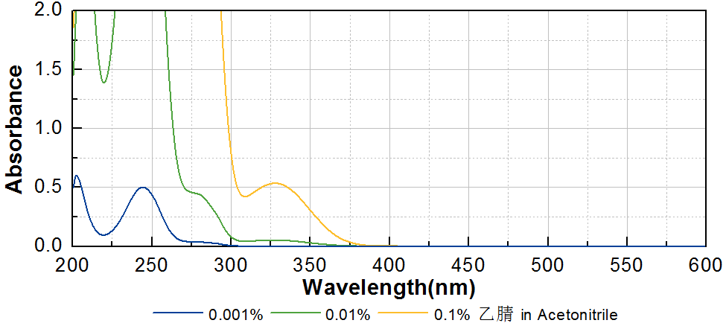
技术参数 Technical Parameters
- 外观 Appearance：白色晶体粉末 White crystalline powder
- 纯度 Purity (GC)：≥98.00%
- 熔程 Melting Range：45.0~50.0ºC
- 干燥失重 Loss on Drying：≤0.50%
产品优势 Benefits
- 抗氧阻聚 Good oxygen polymerization resistance
- 优良的热稳定性 Good thermal stability
- 耐黄变 Good yellowing resistance
应用 Applications
- TR-184可以作为光引发剂，也常作为油墨体系的助引发剂使用。作为光引发剂使用的建议添加量约为3~5%。作为助引发剂使用的建议添加量约为1~3%。
- TR-184 can be used as photoinitiator or as co-initiator in ink. When used as photoinitiator, a level of approximately 3~5% is recommended. When used as co-initiator, a level of 1~3% is recommended.
存储及包装 Storage & Packaging
- 保存在密闭容器中储存在阴凉、干燥、阴暗、通风的区域。自生产日期开始，1年内有效。包装：20kg/箱。
- Keep in a tightly closed container and store in a cool, dry, dark, ventilated area. Effective from the date of production, within 1 years. Packaging: 20kg/carton.

THE END

