TR-379
产品简介 General Information
- TR-379是一款通用型自由基光引发剂，具备高引发活性和优秀的深层固化性能，常作为TR-907的替代品使用。TR-379可与其他光引发剂搭配使用，尤其是和硫杂蒽酮协同使用时，特别适用于有色体系的光固化。
- TR-379 is a free radical photoinitiator with high initiating activity and excellent deep curing performance, usually used as a substitute for TR-907. TR-379 can be used in combination with other photoinitiators, especially suitable for colored curing when used with thioxanthone.
产品信息 Product Information
- 化学名称 Chemical Name：2-(4-甲基苄基)-2-(二甲基氨基)-1-（4-吗啉苯基）-1-丁酮 2-(4-Methybenzyl)-2-(dimethylamino)-1-(4-morpholinopheryl)butan-1-one
- 分子量 Molecular Weight：380.53
- CAS No：119344-86-4
紫外吸收光谱 UV Absorbance Spectrum
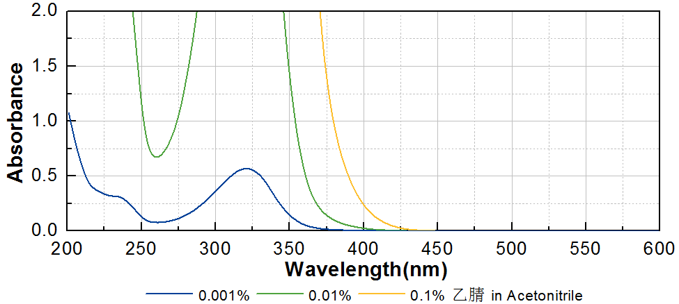

技术参数 Technical Parameters
- 外观 Appearance：淡黄色粉末 Light yellow powder
- 纯度 Purity (HPLC)：≥96.00%
- 熔程 Melting Range：82.0~105.0ºC
产品优势 Benefits
- 高反应活性 High initiating activity
- 长吸收波长 Long absorption wavelength
- 优秀的深层固化性能 Excellent deep curing performance
应用 Applications
- TR-379可用于直接替代TR-907，建议添加量为3~5%。当和硫杂蒽酮协同使用时，例如TR-DETX，特别适用于有色体系的光固化。
- TR-379 can be used to directly replace TR-907; the recommended dosage is 3~5%. It’s especially suitable for colored curing when used with thioxanthone as TR-DETX.
存储及包装 Storage & Packaging
- 保存在密闭容器中储存在阴凉、干燥、阴暗、通风的区域。自生产日期开始，1年内有效。包装：20kg/箱。
- Keep in a tightly closed container and store in a cool, dry, dark, ventilated area. Effective from the date of production, within 1 year. Packaging: 20kg/carton.

THE END

