TR-907
产品简介 General Information
- TR-907是一款通用型自由基光引发剂，具备高引发活性和优秀的深层固化性能。TR-907可与其他光引发剂搭配使用，尤其是和硫杂蒽酮协同使用时，特别适用于有色体系的光固化。
- TR-907 is a free radical photoinitiator with high initiating activity and excellent deep curing performance. TR-907 can be used in combination with other photoinitiators, especially suitable for colored curing when used with thioxanthone.
产品信息 Product Information
- 化学名称 Chemical Name：2-甲基-1-(4-甲硫基苯基)-2-吗啉基-1-丙酮 2-Methyl-1-(4-methylthiophenyl)-2-morpholinopropan-1-one
- 分子量 Molecular Weight：279.40
- CAS No：71868-10-5
紫外吸收光谱 UV Absorbance Spectrum
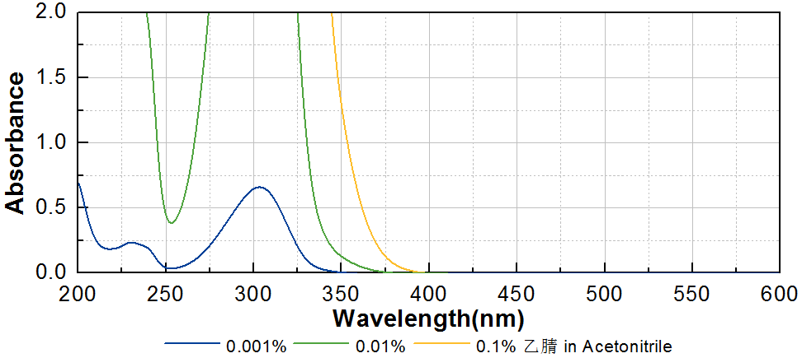
技术参数 Technical Parameters
- 外观 Appearance：白色粉末 White powder
- 纯度 Purity (GC)：≥98.50%
- 熔程 Melting Range：71.0~76.5ºC
产品优势 Benefits
- 极高的反应活性 Very high initiating activity
- 长吸收波长 Long absorption wavelength
- 优秀的深层固化性能 Excellent deep curing performance
应用 Applications
- TR-907由于其强悍的综合性能，被广泛应用于PCB油墨和其他特种油墨。建议添加量为1~3%。当和硫杂蒽酮协同使用时，例如TR-DETX，特别适用于有色体系的光固化。
- TR-907 is widely used in PCB inks and other special inks due to its strong comprehensive performance. The recommended dosage is 1~3%. It’s especially suitable for colored curing when used with thioxanthone as TR-DETX.
存储及包装 Storage & Packaging
- 保存在密闭容器中储存在阴凉、干燥、阴暗、通风的区域。自生产日期开始，1年内有效。包装：20kg/箱。
- Keep in a tightly closed container and store in a cool, dry, dark, ventilated area. Effective from the date of production, within 1 year. Packaging: 20kg/carton.

THE END

