TR-1173
产品简介 General Information
- TR-1173是一款通用型自由基光引发剂，是最为成熟的光引发剂之一。TR-1173由于其优良的性价比和相对平衡的性能，广泛应用于各种光固化材料。
- TR-1173 is a general free radical photoinitiator and one of the most mature photoinitiators. TR-1173 is widely used in UV curing materials due to its excellent cost performance and relatively balanced properties.
产品信息 Product Information
- 化学名称 Chemical Name：2-羟基-2-甲基-1-苯基丙酮 2-Hydroxy-2-methyl-1-phenyl-1-acetone
- 分子量 Molecular Weight：164.20
- CAS No：7473-98-5
紫外吸收光谱 UV Absorbance Spectrum
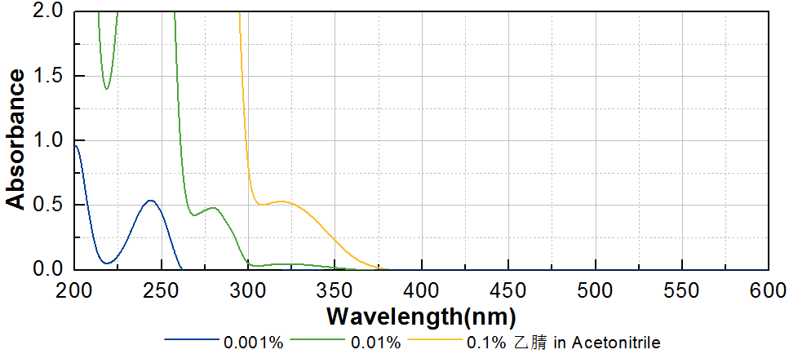
技术参数 Technical Parameters
- 外观 Appearance：浅黄色透明液体 Light yellow transparent liquid
- 纯度 Purity (GC)：≥98.00%
产品优势 Benefits
- 成熟的产品应用 Mature product application
- 高性价比 Excellent cost performance
应用 Applications
- TR-1173广泛应用于光固化材料，尤其适用于木器涂料和简单涂料。建议添加量约为3~5%。
- TR-1173 is widely used in light curing materials, especially for wood coating and basic coating. A level of approximately 3~5% is recommended.
存储及包装 Storage & Packaging
- 保存在密闭容器中储存在阴凉、干燥、阴暗、通风的区域。自生产日期开始，1年内有效。包装：25kg/桶，200kg/桶，1000kg/桶。
- Keep in a tightly closed container and store in a cool, dry, dark, ventilated area. Effective from the date of production, within 1 year. Packaging: 25kg/pail, 200kg/drum, 1000kg/IBC.

THE END

