TR-BDK
产品简介 General Information
- TR-BDK是一款通用型自由基光引发剂，具有优秀的热稳定性、较高的引发活性、良好的溶解性。其良好的热稳定性可用于各种需要耐受较高温度的光固化领域。
- TR-BDK is a general free radical photoinitiator with excellent thermal stability, high initiating activity and good solubility. For its good thermal stability, TR-BDK can be used in applications that need to withstand higher temperature.
产品信息 Product Information
- 化学名称 Chemical Name：安息香双甲醚 2,2-Dimethoxy-2-phenylacetophenone
- 分子量 Molecular Weight：256.30
- CAS No：24650-42-8
紫外吸收光谱 UV Absorbance Spectrum
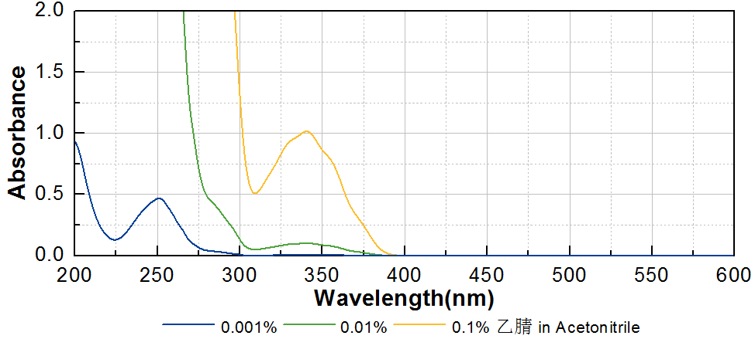
技术参数 Technical Parameters
- 外观 Appearance：白色晶体粉末 White crystalline powder
- 纯度 Purity (HPLC)：≥99.00%
- 干燥失重 Loss on Drying：≤0.50%
产品优势 Benefits
- 优秀的热稳定性 Excellent high-temperature stability
- 高反应活性 High reactivity
- 良好的溶解性 Good solubility
应用 Applications
- TR-BDK由于其极优的热稳定性，常被用于需要耐热的材料或工艺，例如真空电镀。建议添加量为3~5%。
- Because of its excellent thermal stability, TR-BDK is often used in materials or processes requiring heat resistance, such as vacuum electroplating. The recommended dosage is 3-5%.
存储及包装 Storage & Packaging
- 保存在密闭容器中储存在阴凉、干燥、阴暗、通风的区域。温度高于室温时产品易发生熔融导致结块，如出现结块，可在避光条件下粉碎后继续使用。自生产日期开始，2年内有效。包装：20kg/箱。
- Keep in a tightly closed container and store in a cool, dry, dark, ventilated area. When the temperature is higher than normal temperature, the product is easy to melt and cause caking. If caking occurs, it can be crushed under dark conditions and then continue to use. Effective from the date of production, within 2 years. Packaging: 20kg/carton.

THE END

