TR-BP
产品简介 General Information
- TR-BP是一款通用型自由基光引发剂，具有优秀的反应活性和经济适用性。TR-BP也可作为有机合成原料和中间体。
- TR-BP is a general free radical photoinitiator with excellent reactivity and cost effectivity. TR-BP can also be used as organic synthesis raw materials and intermediates.
产品信息 Product Information

- 化学名称 Chemical Name：二苯甲酮 Benzophenone
- 分子量 Molecular Weight：182.22
- CAS No：119-61-9
紫外吸收光谱 UV Absorbance Spectrum
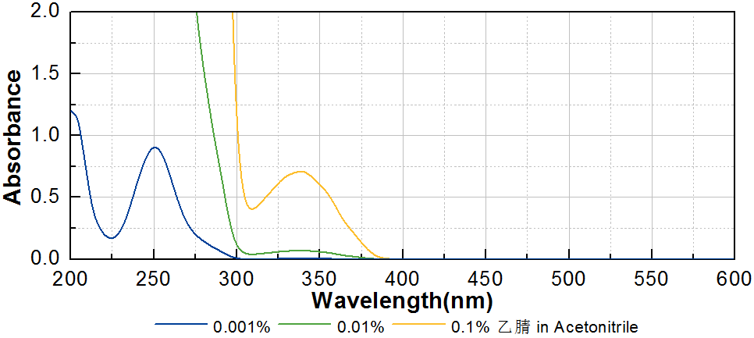
技术参数 Technical Parameters
- 外观 Appearance：白色片状固体 White flake solid
- 纯度 Purity (GC)：≥99.00%
- 熔程 Melting Range：46.0~50.0ºC
产品优势 Benefits
- 高反应活性 High reactivity
- 优秀的性价比 Excellent cost effectivity
应用 Applications
- 建议添加量为3~5%。
- The recommended dosage is 3-5%.
存储及包装 Storage & Packaging
- 保存在密闭容器中储存在阴凉、干燥、阴暗、通风的区域。温度高于室温时产品易发生熔融导致结块，如出现结块，可在避光条件下粉碎后继续使用。自生产日期开始，2年内有效。包装：25kg/袋。
- Keep in a tightly closed container and store in a cool, dry, dark, ventilated area. When the temperature is higher than normal temperature, the product is easy to melt and cause caking. If caking occurs, it can be crushed under dark conditions and then continue to use. Effective from the date of production, within 2 years. Packaging: 25kg/pack.

THE END

