TR-CBP
产品简介 General Information
- TR-CBP是一款通用型自由基光引发剂，常作为TR-BP的改进版使用。TR-CBP具有高引发效率、低气味的特性，广泛应用于木器涂料和光油。
- TR-CBP is a general free radical photoinitiator, often used as an improved version of TR-BP. It’s high initiation efficiency and low odor. It’s widely used in wood coating and varnish.
产品信息 Product Information
- 化学名称 Chemical Name：4-氯二苯甲酮 4-Chlorobenzophenone
- 分子量 Molecular Weight：216.70
- CAS No：134-85-0
紫外吸收光谱 UV Absorbance Spectrum
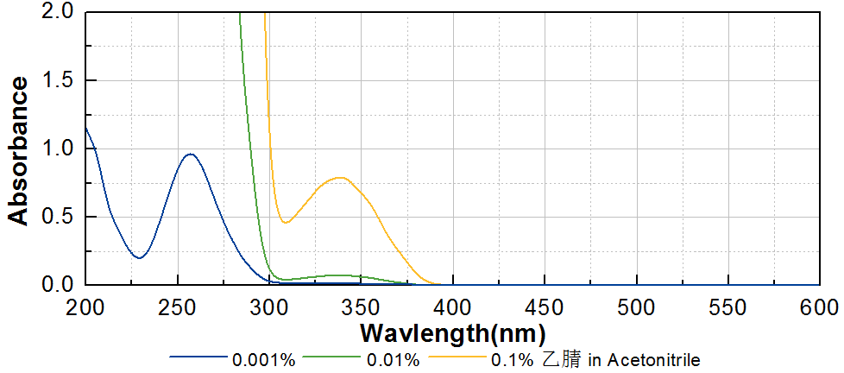
技术参数 Technical Parameters
- 外观 Appearance：白色片状固体 White flaky solid
- 纯度 Purity (HPLC)：≥98.00%
- 熔程 Melting Range：74.0~76.0ºC
- 干燥失重 Loss on Drying：≤0.50%
产品优势 Benefits
- 高反应活性 High reactivity
- 低气味 Low odor
应用 Applications
- TR-CBP可以用于直接替代TR-BP，以获得更低气味的光固化产品，广泛应用在木器涂料和光油。建议添加量为3~5%。
- TR-CBP can be used as a direct substitute for TR-BP to make lower odor UV curing products. TR-CBP is widely used in wood coating and varnish. The recommended dosage is 3~5%.
存储及包装 Storage & Packaging
- 保存在密闭容器中储存在阴凉、干燥、阴暗、通风的区域。自生产日期开始，1年内有效。包装：25kg/箱。
- Keep in a tightly closed container and store in a cool, dry, dark, ventilated area. Effective from the date of production, within 1 year. Packaging: 25kg/carton.

THE END

