TR-DETX
产品简介 General Information
- TR-DETX是一款通用型自由基光引发剂。其可吸收波长长，溶解性好，常被用于和α-羟基酮搭配用于有色体系的固化,例如20400。相比TR-ITX，TR-DETX毒性更低，适用范围更广。TR-DETX与叔胺类协同使用也能获得优秀的引发性能。此外，TR-DETX也可以作为碘鎓盐阳离子引发剂的增感剂使用。
- TR-DETX is a general free radical photoinitiator with long absorption wavelength and good solubility. It is often used for curing colored systems with α-hydroxyl ketone as TR-NPI-20400. Compared with TR-ITX, TR-DETX has lower toxicity and wider scope of application. The combination of TR-DETX and tertiary amine can also obtain excellent initiating performance. In addition, TR-DETX can also be used as sensitizer of iodonium salt cationic initiator.
产品信息 Product Information
- 化学名称 Chemical Name：2,4-二乙基噻唑酮 2,4-diethyl-9H-thioxanthen-9-one
- 分子量 Molecular Weight：268.37
- CAS No：82799-44-8
紫外吸收光谱 UV Absorbance Spectrum
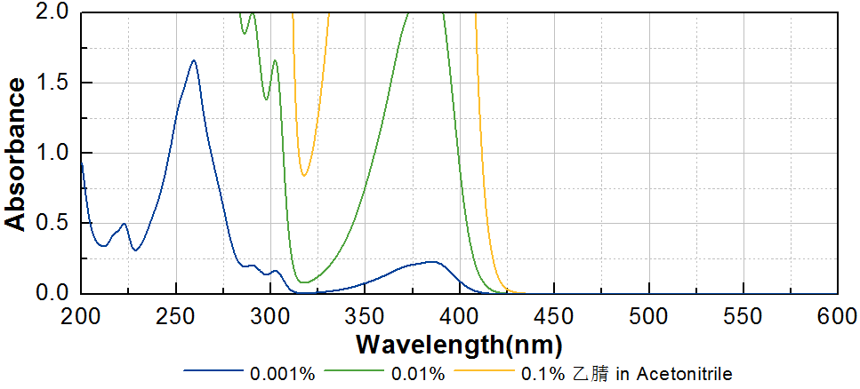
技术参数 Technical Parameters
- 外观 Appearance：黄色粉末 Yellow powder
- 纯度 Purity (HPLC)：≥98.00%
- 熔程 Melting Range：69.0~76.0ºC
- 干燥失重 Loss on Drying：≤0.50%
产品优势 Benefits
- 长吸收波长 Long absorption wavelength
- 优良的溶解性 Good solubility
- 相比TR-ITX较低的毒性 Lower toxicity than TR-ITX
应用 Applications
- TR-DETX主要应用领域是油墨，包括PCB油墨和喷墨。也作为重要的碘鎓盐增感剂广泛应用于阳离子涂料中。作为光引发剂使用的建议添加量约为1~3%。作为增感剂使用的建议添加量约为0.5~1%。
- The main application of TR-DETX is ink, including PCB ink and inkjet. It is also widely used in cationic coatings as an important sensitizer for iodonium salt. When used as photoinitiator, a level of approximately 1~3% is recommended. When used as sensitizer, a level of approximately 0.5~1% is recommended.
存储及包装 Storage & Packaging
- 保存在密闭容器中储存在阴凉、干燥、阴暗、通风的区域。自生产日期开始，1年内有效。包装：20kg/箱。
- Keep in a tightly closed container and store in a cool, dry, dark, ventilated area. Effective from the date of production, within 1 year. Packaging: 20kg/carton.

THE END

