TR-ITX
产品简介 General Information
- TR-ITX是一款通用型自由基光引发剂。其可吸收波长长，溶解性好，常被用于和α-羟基酮搭配用于有色体系的固化，例如20400。TR-ITX与叔胺类协同使用也能获得优秀的引发性能。此外，TR-ITX也可以作为碘鎓盐阳离子引发剂的增感剂使用。
- TR-ITX is a general free radical photoinitiator with long absorption wavelength and good solubility. It is often used for curing colored systems with α-hydroxyl ketone as TR-NPI-20400. The combination of TR-ITX and tertiary amine can also obtain excellent initiating performance. In addition, TR-ITX can also be used as sensitizer of iodonium salt cationic initiator.
产品信息 Product Information
- 化学名称 Chemical Name：2-异丙基硫杂蒽酮 2-Isopropylthioxanthone
- 分子量 Molecular Weight：254.40
- CAS No：5495-84-1
紫外吸收光谱 UV Absorbance Spectrum
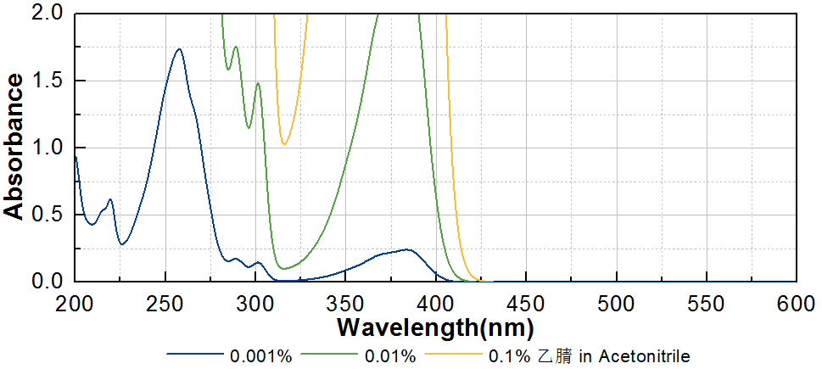
技术参数 Technical Parameters
- 外观 Appearance：淡黄色至类白色粉末 Light yellow to off-white powder
- 纯度 Purity (HPLC)：≥98.00%
- 干燥失重 Loss on Drying：≤0.50%
产品优势 Benefits
- 长吸收波长 Long absorption wavelength
- 优良的溶解性 Good solubility
应用 Applications
- TR-ITX主要应用领域是油墨，包括PCB油墨和喷墨。也作为重要的碘鎓盐增感剂广泛应用于阳离子涂料中。作为光引发剂使用的建议添加量约为1~3%。作为增感剂使用的建议添加量约为0.5~1%。
- The main application of TR-ITX is ink, including PCB ink and inkjet. It is also widely used in cationic coatings as an important sensitizer for iodonium salt. When used as photoinitiator, a level of approximately 1~3% is recommended. When used as sensitizer, a level of approximately 0.5~1% is recommended.
存储及包装 Storage & Packaging
- 保存在密闭容器中储存在阴凉、干燥、阴暗、通风的区域。自生产日期开始，1年内有效。包装：20kg/箱。
- Keep in a tightly closed container and store in a cool, dry, dark, ventilated area. Effective from the date of production, within 1 year. Packaging: 20kg/carton.

THE END

