TR-MBF
产品简介 General Information
- TR-MBF是一款通用型自由基光引发剂，具有高反应活性、低气味、低黄变的特性，适用于各种人体直接接触材料，也适用于耐沾污和表面性能优异的涂料。
- TR-MBF is a general free radical photoinitiator with high reactivity, low odor and low yellowing. It is suitable for all kinds of materials in direct contact with human body, and also for thin coatings which need stain resistance and surface performance.
产品信息 Product Information
- 化学名称 Chemical Name：苯甲酰甲酸甲酯 Methyl Benzoylformate
- 分子量 Molecular Weight：164.16
- CAS No：15206-55-0
紫外吸收光谱 UV Absorbance Spectrum
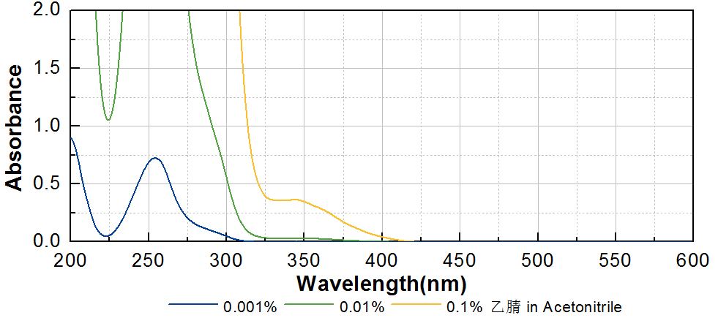
技术参数 Technical Parameters
- 外观 Appearance：淡黄色透明液体 Light yellow transparent liquid
- 纯度 Purity (HPLC)：≥99.00%
产品优势 Benefits
- 高活性 High reactivity
- 低黄变 Very low yellowing
- 低气味 Low odor
- 优秀的表面固化性能 Excellent surface curing performance
应用 Applications
- TR-MBF可应用于各种与人体直接接触材料，尤其是有气味和手感要求的高性能透明涂料。建议添加量为3~5%。
- TR-MBF can be applied to various materials in direct contact with human body, especially high-performance transparent coatings with odor and handle requirement. The recommended dosage is 3~5%.
存储及包装 Storage & Packaging
- 保存在密闭容器中储存在阴凉、干燥、阴暗、通风的区域。自生产日期开始，1年内有效。包装：25kg/桶。
- Keep in a tightly closed container and store in a cool, dry, dark, ventilated area. Effective from the date of production, within 1 year. Packaging: 25kg/pail.

THE END

