TR-NPI-102
产品简介 General Information
- TR-NPI-102是一款通用型自由基光引发剂，常作为TR-BP的改进版使用。TR-NPI-102具有高引发效率、低气味的特性，广泛应用于食品包装油墨和光油。
- TR-NPI-102 is a general free radical photoinitiator, often used as an improved version of TR-BP. It’s high initiation efficiency and low odor. It’s widely used in food packaging ink and varnish.
产品信息 Product Information
- 化学名称 Chemical Name：3-甲基4-苯基二苯甲酮 3-Methyl-4-phenylbenzophenone
- 分子量 Molecular Weight：272.34
- CAS No：86428-83-3
紫外吸收光谱 UV Absorbance Spectrum
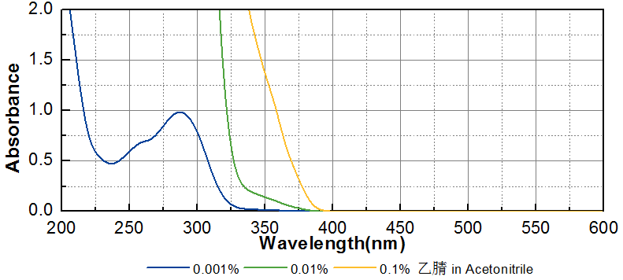
技术参数 Technical Parameters
- 外观 Appearance：类白色至白色粉末 Off-white to white powder
- 纯度 Purity (HPLC)：≥99.00%
- 熔程 Melting Range：81.0~84.0ºC
- 干燥失重 Loss on Drying：≤0.50%
产品优势 Benefits
- 高反应活性 High reactivity
- 低气味 Low odor
应用 Applications
- TR-NPI-102广泛应用在食品包装油墨和光油。建议添加量为3~5%。
- TR-NPI-102 is widely used in food packaging ink and varnish. The recommended dosage is 3~5%.
存储及包装 Storage & Packaging
- 保存在密闭容器中储存在阴凉、干燥、阴暗、通风的区域。自生产日期开始，1年内有效。包装：20kg/箱。
- Keep in a tightly closed container and store in a cool, dry, dark, ventilated area. Effective from the date of production, within 1 year. Packaging: 20kg/carton.

THE END

