TR-NPI-501
产品简介 General Information
- TR-NPI-501是一款新型自由基光引发剂，具有高反应活性、低气味、低迁移、低黄变的特性。TR-NPI-501在水中有良好的溶解性，适用于大多数水性光固化体系。
- TR-NPI-501 is a new free radical photoinitiator with high reactivity, low odor, low migration and low yellowing. TR-NPI-501 has good solubility in water, and it’s suitable for most water-borne UV curing systems.
产品信息 Product Information
- 化学名称 Chemical Name：2-羟基-2-甲基-1-[4-(2-羟基乙氧基)苯基]-1-丙酮
2-Hydroxy-4'-(2-hydroxyethoxy)-2- methylpropiophenone
- 分子量 Molecular Weight：224.25
- CAS No：106797-53-9
紫外吸收光谱 UV Absorbance Spectrum
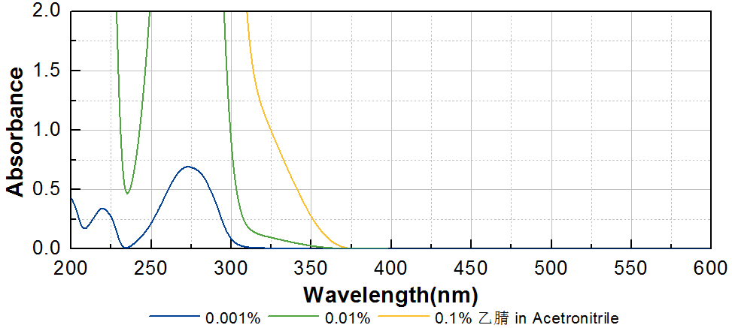
技术参数 Technical Parameters
- 外观 Appearance：白色粉末 White powder
- 纯度 Purity (HPLC)：≥98.00%
- 干燥失重 Loss on Drying：≤0.50%
产品优势 Benefits
- 高活性 High reactivity
- 低黄变 Low yellowing
- 低气味、低迁移 Low odor and low migration
- 优良的水溶性 Good solubility in water
应用 Applications
- TR-NPI-501主要应用于各种水相关光固化体系，例如水性光固化涂料和需要调节水油平衡的油墨。建议添加量为1~3%。
- TR-NPI-501 It is mainly used in water-related UV curing, such as water-based UV curing coatings and inks that need to adjust the water-oil balance. The recommended dosage is 1~3%.
存储及包装 Storage & Packaging
- 保存在密闭容器中储存在阴凉、干燥、阴暗、通风的区域。自生产日期开始，1年内有效。包装：20kg/箱。
- Keep in a tightly closed container and store in a cool, dry, dark, ventilated area. Effective from the date of production, within 1 year. Packaging: 20kg/carton.

THE END

