TR-NPI-601
产品简介 General Information
- TR-NPI-601是一款通用型自由基光引发剂，具备高固化活性、较长的吸收波长、优秀的深层固化性能、光漂白性，特别适用于LED涂料和油墨中使用。
- TR-NPI-601 is a general free radical photoinitiator with high curing activity, long absorption wavelength, excellent deep curing performance, and photo-bleaching property. It is particularly suitable for LED curing coatings and inks.
产品信息 Product Information
- 化学名称 Chemical Name：苯基双(2,4,6-三甲基苯甲酰基)氧化膦 Bis(2,4,6-trimethylbenzoyl) phenylphosphine oxide
- 分子量 Molecular Weight：418.46
- CAS No：162881-26-7
紫外吸收光谱 UV Absorbance Spectrum
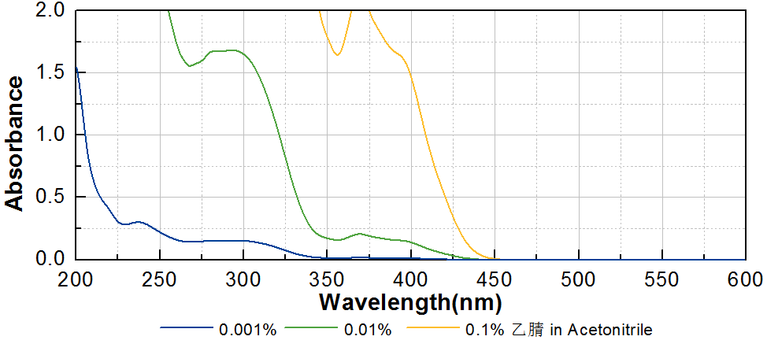
技术参数 Technical Parameters
- 外观 Appearance：淡黄色粉末 Light yellow powder
- 纯度 Purity (HPLC)：≥98.00%
- 干燥失重 Loss on Drying：≤0.50%
- 熔程 Melting Range：127~135ºC
产品优势 Benefits
- 优秀的引发活性 High curing activity
- 长吸收波长 Long absorption wavelength
- 优秀的深层固化性能 Excellent deep curing performance
- 光漂白性，抗黄变 Good yellow resistance and photo-bleaching property
应用 Applications
- TR-NPI-601通常作为TR-TPO的活性改良版本使用，在实际应用中两种引发剂经常搭配使用。建议添加量约为1~3%。
- TR-NPI-601 is usually used as a better activity version of TR-TPO, and the two initiators are often used together in practical applications. The recommended addition amount is about 1~3%.
存储及包装 Storage & Packaging
- 保存在密闭容器中储存在阴凉、干燥、阴暗、通风的区域。自生产日期开始，18个月内有效。包装：20kg/箱。
- Keep in a tightly closed container and store in a cool, dry, dark, ventilated area. Effective from the date of production, within 18 months. Packaging: 20kg/carton.

THE END

