TR-NPI-602
产品简介 General Information
- TR-NPI-602是一款通用型自由基光引发剂，具备较长的吸收波长、优秀的深层固化性能、光漂白性，特别适用于LED涂料和油墨中使用。TR-NPI-602还拥有更高的纯度和更严格的规格，可以应用于高要求领域。
- TR-NPI-602 is a general free radical photoinitiator with long absorption wavelength, excellent deep curing performance and photo-bleaching property. It is particularly suitable for LED curing coatings and inks. TR-NPI-602 also has higher purity and more strictent specifications, which can be used in fields with high requirements.
产品信息 Product Information
- 化学名称 Chemical Name：2,4,6-三甲基苯甲酰二苯氧膦 Diphenyl(2,4,6-trimethylbenzoyl) phosphine oxide
- 分子量 Molecular Weight：348.38
- CAS No：75980-60-8
紫外吸收光谱 UV Absorbance Spectrum
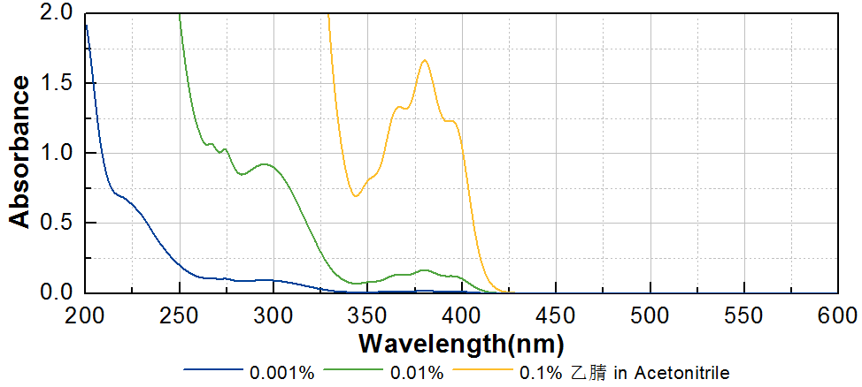
技术参数 Technical Parameters
- 外观 Appearance：淡黄色粉末 Light yellow powder
- 纯度 Purity (HPLC)：≥99.00%
- 熔程 Melting Range：85.0~95.0ºC
- 酸值 Acid Value：≤0.25mg KOH/g
产品优势 Benefits
- 长吸收波长 Long absorption wavelength
- 优秀的深层固化性能 Excellent deep curing performance
- 光漂白性，抗黄变 Good yellow resistance and photo-bleaching property
- 电子级规格 Electronic grade specification
应用 Applications
- TR-NPI-602是更高规格的，用于电子领域的TR-TPO，具体使用方式和特性大致和TR-TPO相同。TR-NPI-602主要用于电子电路材料中的封装和粘接，建议添加量约为1~3%。
- TR-NPI-602 is a higher specification TR-TPO used in the electronic field. Its specific usage and characteristics are roughly the same as TR-TPO. TR-NPI-602 is mainly used for packaging and bonding in electronic circuit materials, and the recommended amount is about 1~3%.
存储及包装 Storage & Packaging
- 保存在密闭容器中储存在阴凉、干燥、阴暗、通风的区域。自生产日期开始，1年内有效。包装：20kg/箱。
- Keep in a tightly closed container and store in a cool, dry, dark, ventilated area. Effective from the date of production, within 1 year. Packaging: 20kg/carton.

THE END

