TR-NPI-701
产品简介 General Information
- TR-NPI-701是一款双官能团自由基光引发剂，具有高反应活性、低挥发、低迁移、低毒性、低黄变的特性，适用于各种人体直接接触材料。其独特的亲水性也适用于水性光固化体系。
- TR-NPI-701 is a bifunctional free radical photoinitiator with high reactivity, low volatility, low migration, low toxicity and low yellowing. It is suitable for all kinds of materials in direct contact with human body. Its unique hydrophilicity is also suitable for waterborne UV curing system.
产品信息 Product Information
- 化学名称 Chemical Name：苯乙酸a-氧代-1,1'-(氧代-2,1-乙烷基)酯及其单酯
Benzeneacetic acid a-oxo-1,1'-(oxydi-2,1-ethanediyl) ester and its monoester
- 分子量 Molecular Weight：370.35
- CAS No：211510-16-6
紫外吸收光谱 UV Absorbance Spectrum
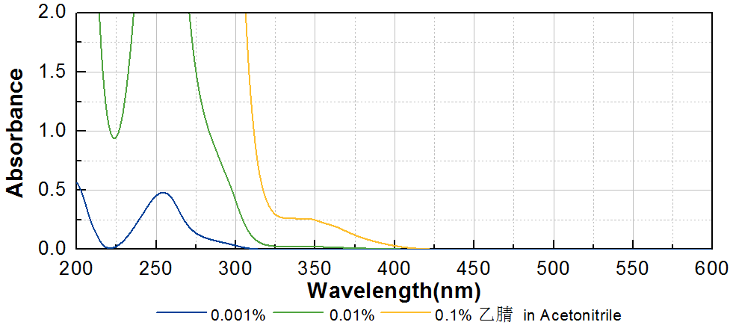
技术参数 Technical Parameters
- 外观 Appearance：浅黄色液体 Light yellow liquid
- 纯度 Purity：≥95.00%
- TR-MBF含量 TR-MBF Content：≤5.00%
产品优势 Benefits
- 高活性 High reactivity
- 低黄变 Low yellowing
- 低气味、低迁移、低毒性 Low odor, low migration, low toxicity
- 水性体系可用 Waterborne system usability
应用 Applications
- TR-NPI-701可应用于各种与人体直接接触材料，例如涂料和食品包装油墨。其独特的亲水性也适用于水性光固化体系。建议添加量为3~5%。
- TR-NPI-701 can be applied to various materials in direct contact with human body, such as coating and food packaging ink. Its unique hydrophilicity is also suitable for waterborne UV curing system. The recommended dosage is 3~5%.
存储及包装 Storage & Packaging
- 保存在密闭容器中储存在阴凉、干燥、阴暗、通风的区域。在20ºC以下储存时可能产生结晶，加热溶解后可正常使用。自生产日期开始，1年内有效。包装：25kg/桶。
- Keep in a tightly closed container and store in a cool, dry, dark, ventilated area. Crystallization may occur when stored below 20 º C. it can be used normally after heating and dissolution. Effective from the date of production, within 1 year. Packaging: 25kg/pail.

THE END

