TR-NPI-801
产品简介 General Information
- TR-NPI-801是一款专为长波长固化定制的自由基光引发剂。其在近可见光波长内有良好的吸收，同时具备优秀的深层固化性能。TR-NPI-801适用于牙科材料和其他特种应用。
- TR-NPI-801 is a free radical photoinitiator specially designed for long-wavelength curing. It has good absorbance in the near-visible UV wavelength, and has excellent deep curing performance. TR-NPI-801 is suitable for dental materials and other special applications.
产品信息 Product Information
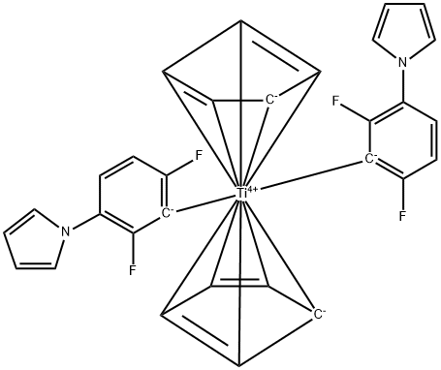
- 化学名称 Chemical Name：双2,6-二氟-3-吡咯苯基二茂钛 Bis(2,6-difluoro-3-(1-hydropyrrol-1-yl)phenyl)titanocene
- 分子量 Molecular Weight：524.30
- CAS No：125051-32-3
紫外吸收光谱 UV Absorbance Spectrum
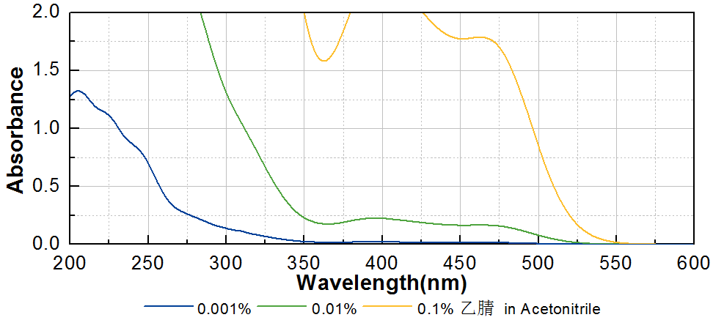
技术参数 Technical Parameters
- 外观 Appearance：橙色粉末 Orange powder
- 纯度 Purity (HPLC)：≥99.00%
- 干燥失重 Loss on Drying：≤0.50%
- 熔程 Melting Range：165~170ºC
产品优势 Benefits
- 优秀的引发活性 High curing activity
- 超长吸收波长 Very long absorption wavelength
- 优秀的深层固化性能 Excellent deep curing performance
应用 Applications
- TR-NPI-801在需要超长吸收波长的应用领域有不可替代性。尤其是波长在400nm以上的可见光固化，TR-NPI-801是最佳选择。建议添加量约为1~3%。
- TR-NPI-801 is irreplaceable in applications requiring ultra-long absorption wavelength. Especially for visible light curing with wavelength above 400nm, TR-NPI-801 is the best choice. The recommended addition amount is about 1~3%.
存储及包装 Storage & Packaging
- 保存在密闭容器中储存在阴凉、干燥、阴暗、通风的区域。储存和使用时需要严格避光。自生产日期开始，1年内有效。包装：1kg/瓶。
- Keep in a tightly closed container and store in a cool, dry, dark, ventilated area. Please store and use in strict dark. Effective from the date of production, within 1 year. Packaging: 1kg/bottle.

THE END

