TR-NPI-11301
产品简介 General Information
- TR-NPI-11301是一款高效自由基光引发剂，具备高引发效率、低气味、低迁移的特性，同时具备良好的溶解性。
- TR-NPI-11301 is an efficiently free radical photoinitiator with high initiation efficiency, low odor, low migration and good solubility.
产品信息 Product Information
- 化学名称 Chemical Name：保密 Confidential
- 分子量 Molecular Weight：保密 Confidential
- CAS No：无资料 Not available
紫外吸收光谱 UV Absorbance Spectrum
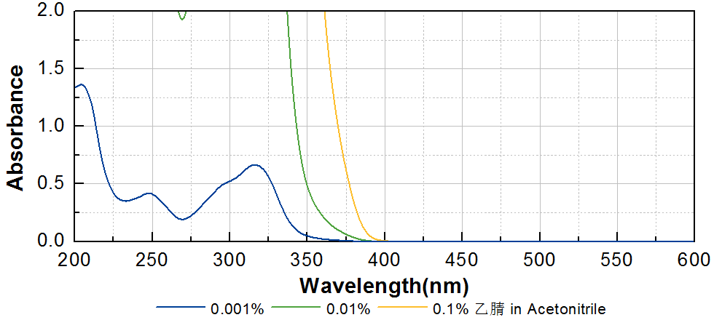
技术参数 Technical Parameters
- 外观 Appearance：类白色粉末 Off-white powder
- 纯度 Purity (HPLC)：≥98.00%
产品优势 Benefits
- 高活性 High reactivity
- 低气味、低迁移、低毒性 Low odor, low migration, low toxicity
- 低氧阻聚 Low oxygen polymerization inhibition
应用 Applications
- TR-NPI-11301可应用于各种与人体直接接触材料，例如涂料和食品包装油墨。建议添加量为3~5%。
- TR-NPI-11301 can be applied to various materials in direct contact with human body, such as coating and food packaging ink. The recommended dosage is 3~5%.
存储及包装 Storage & Packaging
- 保存在密闭容器中储存在阴凉、干燥、阴暗、通风的区域。自生产日期开始，2年内有效。包装：20kg/桶。
- Keep in a tightly closed container and store in a cool, dry, dark, ventilated area. Effective from the date of production, within 2 years. Packaging: 20kg/drum.

THE END

