TR-NPI-20400
产品简介 General Information
- TR-NPI-20400是一款通用型自由基光引发剂，具备高引发活性和优秀的深层固化性能，具备无生殖毒性、低气味、低迁移的特性，以及良好的溶解性和优秀的热稳定性，常作为TR-907的替代品使用。TR-NPI-20400可与其他光引发剂搭配使用，尤其是和硫杂蒽酮协同使用时特别适用于有色体系的光固化。
- TR-NPI-20400 is a general free radical photoinitiator with high initiating activity and excellent deep curing performance, as well as non-reproductive toxic, low odor, low migration, good solubility, excellent thermal stability. It’s usually used as a substitute for TR-907. TR-NPI-20400 can be used in combination with other photoinitiators, especially suitable for colored curing when used with thioxanthone.
产品信息 Product Information
- 化学名称 Chemical Name：1-(9，9-二丁基-9H-芴-2-基)-2-甲基-2-吗啉-4-基-丙烷-1-酮 1-(9,9-Dibutyl-9H-fluoren-2-yl)-2-methyl-2-morpholin-4-yl-propan-1-one
- 分子量 Molecular Weight：433.64
- CAS No：2020359-04-8
紫外吸收光谱 UV Absorbance Spectrum
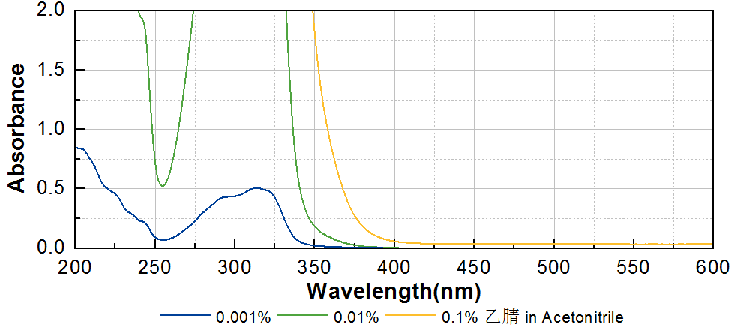

技术参数 Technical Parameters
- 外观 Appearance：类白色至浅黄色粉末 Off-white to light yellow powder
- 纯度 Purity (HPLC)：≥98.50%
- 干燥失重 Loss on Drying：≤0.50%
- 熔程 Melting Range：63.0~73.0ºC
产品优势 Benefits
- 高反应活性 High initiating activity
- 长吸收波长 Long absorption wavelength
- 无生殖毒性、低气味、低迁移 Non reproductive toxic, low odor, low migration
- 良好的溶解性 Good solubility
- 优秀的热稳定性 Excellent thermal stability
- 优秀的深层固化性能 Excellent deep curing performance
应用 Applications
- TR-NPI-20400可用于直接替代TR-907，添加比例为TR-907的1.3~1.5倍，建议添加量为3~5%。当和硫杂蒽酮协同使用时，例如TR-DETX，特别适用于有色体系的光固化。
- TR-NPI-20400 can be used to directly replace TR-907; the addition amount is 1.3~1.5 times of TR-907. The usual recommended dosage is 3~5%. It’s especially suitable for colored system when used with thioxanthone as TR-DETX.
存储及包装 Storage & Packaging
- 保存在密闭容器中储存在阴凉、干燥、阴暗、通风的区域。自生产日期开始，2年内有效。包装：20kg/桶。
- Keep in a tightly closed container and store in a cool, dry, dark, ventilated area. Effective from the date of production, within 2 years. Packaging: 20kg/drum.

THE END

