TR-NPI-50103
产品简介 General Information
- TR-NPI-50103是一款双官能团自由基光引发剂，具有高反应活性、低挥发、低迁移、低毒性、低黄变的特性，适用于各种人体直接接触材料，也适用于氧阻聚影响较大的薄涂层。
- TR-NPI-50103 is a bifunctional free radical photoinitiator with high reactivity, low volatility, low migration, low toxicity, and low yellowing. It is suitable for all kinds of materials in direct contact with human body, and also for thin coatings with large impact of oxygen polymerization inhibition.
产品信息 Product Information
- 化学名称 Chemical Name：2-羟基-1-[4-[4-(2-羟基-2-甲基-丙酰基)-苯氧基]-苯基]-2-甲基-丙-1-酮 2-Hydroxy-1-[4-[4-(2-hydroxy-2-methylpropanoyl) phenoxy] phenyl]-2-methylpropan-1-one
- 分子量 Molecular Weight：342.39
- CAS No：71868-15-0
紫外吸收光谱 UV Absorbance Spectrum
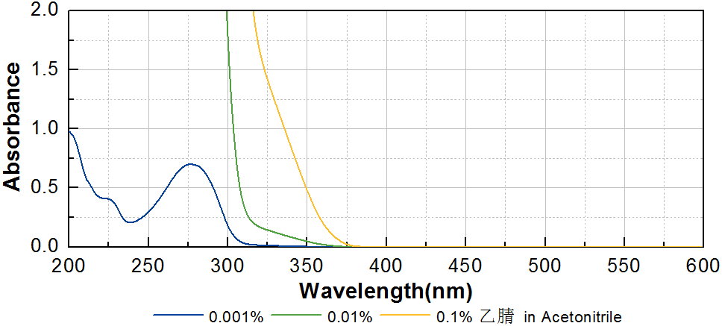

技术参数 Technical Parameters
- 外观 Appearance：类白色粉末 Off-white powder
- 纯度 Purity (HPLC)：≥98.00%
- 水份 Water Content：≤0.50%
产品优势 Benefits
- 高活性 High reactivity
- 低黄变 Low yellowing
- 低气味、低迁移、低毒性 Low odor, low migration, low toxicity
- 低氧阻聚 Low oxygen polymerization inhibition
- 适用范围广泛 Wide application range
应用 Applications
- TR-NPI-50103可应用于各种与人体直接接触材料，例如涂料和食品包装油墨。建议添加量为3~5%，当与活性胺助剂协同使用时，可以获得更好的固化性能，显著提升深层固化。
- TR-NPI-50103 can be applied to various materials in direct contact with human body, such as coating and food packaging ink. The recommended dosage is 3~5%. It shows better curing performance when used in conjunction with active amine assistant, and the deep curing can be significantly improved.
存储及包装 Storage & Packaging
- 保存在密闭容器中储存在阴凉、干燥、阴暗、通风的区域。自生产日期开始，1年内有效。包装：20kg/桶。
- Keep in a tightly closed container and store in a cool, dry, dark, ventilated area. Effective from the date of production, within 1 years. Packaging: 20kg/drum.

THE END

