TR-OBM
产品简介 General Information
- TR-OBM是一款通用型自由基光引发剂，具有高引发效率、低气味、无毒的特性，适用于各种人体直接接触材料。TR-OBM可以与TR-TPO协同使用，获得更高的固化性能。
- TR-OBM is a general free radical photoinitiator with high initiation efficiency, low odor and non-toxic characteristics, which is suitable for all kinds of human direct contact materials. TR-OBM can be used together with TR-TPO to obtain higher curing performance.
产品信息 Product Information
- 化学名称 Chemical Name：邻苯甲酰苯甲酸甲酯 Methyl 2-benzoylbenzoate
- 分子量 Molecular Weight：240.26
- CAS No：606-28-0
紫外吸收光谱 UV Absorbance Spectrum
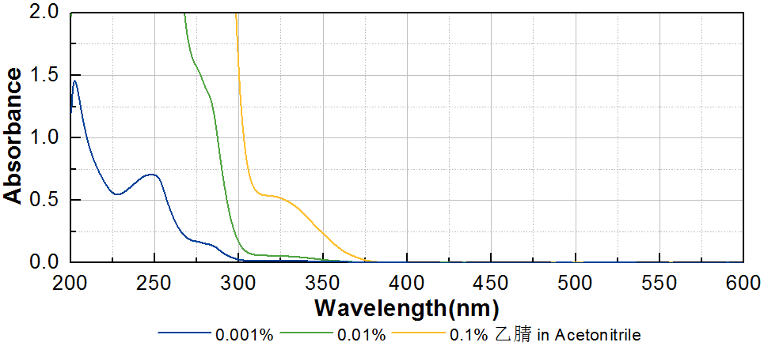

技术参数 Technical Parameters
- 外观 Appearance：白色晶体粉末 White crystalline powder
- 纯度 Purity (HPLC)：≥99.00%
- 熔程 Melting Range：48.0~54.0ºC
- 干燥失重 Loss on Drying：≤0.40%
产品优势 Benefits
- 高反应活性 High reactivity
- 低气味，无毒 Low odor and non-toxic
应用 Applications
- TR-OBM可应用于各种与人体直接接触材料，例如涂料和食品包装油墨。建议添加量为3~5%，当与TR-TPO协同使用时，可以获得更好的固化性能。
- TR-OBM can be applied to various materials in direct contact with human body, such as coating and food packaging ink. The recommended dosage is 3~5%. It shows better curing performance when used in conjunction with TR-TPO.
存储及包装 Storage & Packaging
- 保存在密闭容器中储存在阴凉、干燥、阴暗、通风的区域。温度高于室温时产品易发生熔融导致结块，如出现结块，可在避光条件下粉碎后继续使用。自生产日期开始，2年内有效。包装：20kg/箱。
- Keep in a tightly closed container and store in a cool, dry, dark, ventilated area. When the temperature is higher than normal temperature, the product is easy to melt and cause caking. If caking occurs, it can be crushed under dark conditions and then continue to use. Effective from the date of production, within 2 years. Packaging: 20kg/carton.

THE END

