TR-TPO-L
产品简介 General Information
- TR-TPO-L是一款通用型自由基光引发剂，具备较长的吸收波长、优秀的深层固化性能、光漂白性，特别适用于LED涂料和油墨中使用。
- TR-TPO-L is a free radical photoinitiator with long absorption wavelength, excellent deep curing performance, and photo-bleaching property. It is particularly suitable for use in LED curing coatings and inks.
产品信息 Product Information
- 化学名称 Chemical Name：2,4,6-三甲基苯甲酰基苯基膦酸乙酯 Ethyl (2,4,6-trimethylbenzoyl) phenylphosphinate
- 分子量 Molecular Weight：316.34
- CAS No：84434-11-7
紫外吸收光谱 UV Absorbance Spectrum
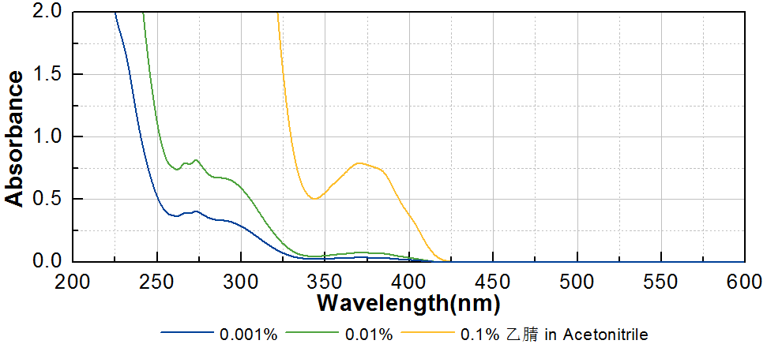
技术参数 Technical Parameters
- 外观 Appearance：淡黄色透明液体 Light yellow transparent liquid
- 纯度 Purity (GC)：≥98.00%
产品优势 Benefits
- 长吸收波长 Long absorption wavelength
- 优秀的深层固化性能 Excellent deep curing performance
- 光漂白性，抗黄变 Good yellow resistance and photo-bleaching property
- 相比TR-TPO更易使用，气味更低 Easier to use and lower odor than TR-TPO
应用 Applications
- TR-TPO-L由于在LED固化领域中优良的性能，被广泛应用于光固化涂料和油墨。当和TR-184协同使用时能够获得更平衡的性能表现。涂料中的建议添加量约为1~3%，油墨中的建议添加量约为5~10%。
- TR-TPO-L is widely used in coating and ink due to its excellent performance in LED curing. It can achieve more balanced performance when used with TR-184. The recommended addition amount in coating is about 1~3%, and that in ink is about 5~10%.
存储及包装 Storage & Packaging
- 保存在密闭容器中储存在阴凉、干燥、阴暗、通风的区域。自生产日期开始，1年内有效。包装：25kg/桶。
- Keep in a tightly closed container and store in a cool, dry, dark, ventilated area. Effective from the date of production, within 1 year. Packaging: 25kg/pail.

THE END

